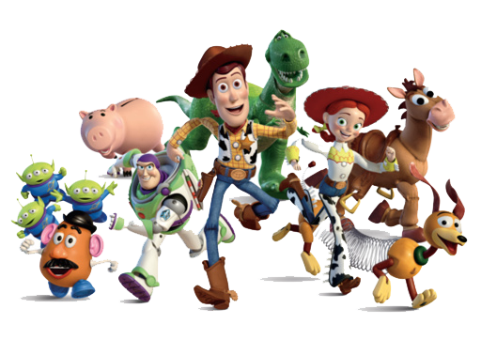
This term we will be looking at the place value and composition of the numbers 0-10. We will also be focusing on odd and even numbers, and addition and subtraction before moving on to telling the time to o’clock. We will be learning the days of the week and the months of the year.
We will also be working on number formation.

Our music theme is Move to the Beat. We will learn to recognise pulse through matching movements to music. We will explore percussion instruments and perform simple accompaniments to familiar songs. We will start to use vocabulary such as tempo, pitch and dynamics.

We will identify a computer and its main parts and learn how to use a mouse in different ways. We will learn how to use a keyboard to type and edit text and create rules for using technology responsibly.

In science, we will be learning about ourselves; naming parts of our bodies and thinking about how we use our senses. We will learn about what a healthy lifestyle is.
We will also be finding out the differences between deciduous and evergreen trees and the four seasons.

As Digital Citizens
As Mathematicians
As Musicians
As Scientists
We will be exploring self-portraits using colour, line, and shape. We will use various brushes to create lines of different thickness using paint. We will explore a variety of artists and learn to express our opinions.

As Artists
ALL CHILDREN MUST COME TO SCHOOL IN THEIR PE KITS ON FRIDAYS.
On Fridays, we are learning ball skills to enable us to throw, roll, dribble, and bounce balls of various sizes. We will use these skills to pass and score with control and accuracy in new games learnt.

As Athletes
Our English lessons are a daily hour of Read, Write Inc, completing phonics, reading, and writing tasks.
In our daily Whole Class Guiding Reading sessions, we will be reading a range of books related to our topic – Toys. We will begin to think about the texts more carefully and start to answer questions and complete short tasks to help our reading comprehension.
In our RE lessons we will think about aspects of identity shown in family, community, and the choices we make. We will hear some religious stories about who we are and talk about some beliefs linked to these stories. We will discover that some objects are special because they can help us answer the question: who am I? We will use material from the Christian religion to explore questions about identity and belonging.
As Readers and Writers
Read with your child daily and sign their reading diary. Please encourage your child to get dressed by themselves, including socks and shoes to promote their independence.
We will learn to identify patterns in the weather and to identify the seasons.
We will make comparisons of day-to-day weather.

As Theologians
How parents can help
Year One – Topic: Toys
As Geographers
In History we will be learning about toys from the past and toys in the present. We will investigate how toys move – with a push or a pull. We will explore Victorian toys during a Herbert Art Gallery workshop.
As Historians

