We will be looking at place value of numbers to 100. We will be exploring equations and solving missing number problems. We will begin to look at multiplication and division, counting in twos, fives and tens.

In music, we will be exploring pitch. We will be listening to, recalling, and playing a series of high and low sounds. We will also be writing our own lyrics to a song!
In DT, we will be designing and making a healthy fruit salad. We will also design and make a hand puppet.
As Design & Technologistss
As Mathematicians
As Musicians
We will create pieces of art comparing Coventry to Kenya. We will explore different textures, shape and colour.

ALL CHILDREN MUST WEAR THEIR PE KITS ON WEDNESDAY.
We will be developing our athletic skills and improving our personal bests.

As Athletes
We will be continuing with Read, Write, Inc. This includes using the sounds we have learnt in reading and writing tasks. We will be improving our handwriting.
In whole class guided reading lessons we will be reading fiction and non-fiction books relating to our topic and developing our comprehension skills.

As part of our PSHE lessons this term, we will be exploring the topic – Relationships.
We will look at what makes a good friend, explore how it feels to belong and how we care about those people who are special to us.
Read with your child daily and sign their reading diary.
Encourage your child to use the Numbots game to improve their maths skills.
Please practise the weekly maths skills sheet which will be sent home with your child.

In history we will be learning about the history makers of flight. We will look at first time ever events in our life and then learn about firs time ever events in history to do with flight. We will learn about the history of flight by exploring, the Wright Brothers, Amelia Earheart, Concorde and the first moon landing. We will put these events onto a timeline and learn about the significance of each and how they made history.

How parents can help
Year One – Topic: History Makers
As Artists
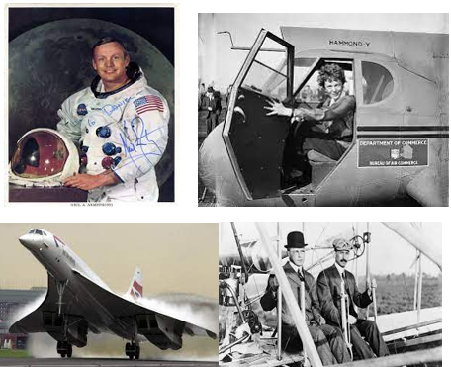
As Historians
As Scientists
In science, we will be learning about invertebrates and developing our field work skills to explore these insects. We will think about what equipment we need to do this. We will look at the structure of common animals and label the body parts. We will complete a field work activity looking at snails and asking questions.

As Citizens
As Readers and Writers

