Henley Green Primary School
Forest School
Handbook

Contents

- Introduction to Forest School
- Provision, communication and environmental impact
- Forest School Rules
- Staff and helpers at Forest School
- Health and safety, Risk Management
- First Aid
- Emergency procedures
- Daily Operating Procedure –before, during and following a session
- Cancellation Policy
- Toileting Policy
- Parental Consent and confidentiality
- Clothing Policy
- Tool Handling Policy
- Fire Policy
- Food and eating Policy
Tree climbing policy
- Safeguarding Children
Safeguarding at Forest Schools
- Safeguarding adults
Lost or missing child policy
- Behaviour
- Roles and responsibilities of adults and children
- Evaluating Monitoring and assessment
- Appendices

What are Forest Schools?

“A Forest School is an innovative educational approach to outdoor play and learning.”
The philosophy of Forest Schools is to encourage and inspire individuals of any age through positive outdoor experiences.
By participating in engaging, motivating and achievable tasks and activities in a woodland environment each participant has an opportunity to develop intrinsic motivation, sound emotional and social skills. These, through self - awareness can be developed to reach personal potential.
Forest Schools has demonstrated success with children of all ages who visit the same local woodlands on a regular basis and through play, who have the opportunity to learn about the natural environment, how to handle risks and most importantly to use their own initiative to solve problems and co-operate with others. Forest School programmes run throughout the year, for about 36 weeks, going to the woods in all weathers (except for high winds). Children use full sized tools, play, learn boundaries of behaviour; both physical and social, establish and grow in confidence, self-esteem and become self-motivated.

Forest Schools will aim to develop:
- Self Awareness
- Self Regulation
- Intrinsic motivation
- Empathy
- Good social communication skills
- Independence
- A positive mental attitude, self-esteem and confidence

Forest School, through its application of Accelerated Learning techniques creates a unique learning vehicle that is used to encourage a range of individuals, community groups and larger organisations to utilise their local open space for interactive play, health, recreation and personal development uses.

Children, and increasingly, adults need time to thoroughly explore their thoughts, feelings and relationships.
This time and reflective practice develops understanding of the world, the environment and everything within it through the use of emotions, imagination and senses.

At Henley Green Primary School the focus of Forest Schools is to actively embrace the potential of using the outdoors as a learning resource and increase focus on healthy lifestyles and environmental sustainability. Learning outdoors should not just be another subject, but rather a medium for an approach to learning and personal development that can be applied to many areas of learning and educational experience.

Provision
At Henley Green Primary School, we aim to ensure that every child receives their entitlement to an experience of outdoor learning: on educational visits, onsite with their class teachers, involvement in gardening projects or as part of Forest Schools. These experiences will be carefully mapped across the curriculum within year groups.
This will be rotated to give children the opportunity to experience the changing seasons. In addition to Forest schools we encourage outdoor cross curricular learning throughout the school.

Communication
To enable the successful operating of Forest Schools, key stakeholders (Head teacher,
Governors, Parents) will be informed of the aims, objectives and outcomes in a variety of
ways periodically throughout the year.

Environmental Impact
At Henley Green Primary School we aim to teach children about caring for the environment in a variety of ways from creating habitats to using non-native species, where possible, for craft activities.
There is a woodland management plan in place, with objectives to minimise the impact of
activities on the site. We aim to balance the benefits the woodland provides the children
with care for the environment.

Forest School Rules

In the first Forest School session, children become involved with the setting and
understanding of the Forest School rules to ensure their safety. At the beginning of every
session a quick recap of the rules is reinforced by the children.

Forest School Rules
Walk within the Forest School Area
Keep everything out of your mouth
Stay within the boundary
Kneel near the pond (when in nature area)
Do not throw anything
Drag sticks behind you
Care for nature
Ask an adult before you use any tool and follow the tool rules
Have FUN!
Always wash hands following a session.

It is important that the adults involved try to help children understand the importance of
these rules, and support children in understanding that Forest School will become too
dangerous if these rules aren’t followed, which may mean that Forest School sessions have
to end.

Staff and Helpers at Forest Schools

Lisa Windmill - Forest School Leader
Forest School Level 3 in Forest School Leadership
Forest School First Aid (16 hour) – Spring 2022
ITC Level 3 in Paediatric First Aid - Spring 2022

Lucy Holt – Nurture Teacher
Forest School Leader in training

Tommy Sheridan – SSO
Forest School assistant
First Aid at Work – June 2021

Forest Schools is carried out with an adult to child ratio of at least 1:8, but additional adult
support will be provided where appropriate for children who have disability or significant SEN needs. When using tools, a definitive adult to child ratio is determined, please see section on tool policies. A separate activity risk assessment will carried out for each activity, when any hazards associated with that activity are at risk of causing harm, ratios for each activity will be determined by the type of activity, the competence of the children and the level of risk involved. All staff are DBS checked and helpers supporting the Forest School leader will not be left to supervise children alone.

All staff and adults involved in Forest Schools, are required to sign and date a form to show that they have read this handbook, appropriate risk assessments and understand to comply with the safety guidelines.

Health and Safety

At Henley Green Primary School, the health and safety of the children, staff and visitors is our primary concern. The following policies within this handbook are in addition to the main school policies and do not replace them including Health and Safety at Work Act 1974. They are the minimum requirements for the safe running of Forest Schools.
Forest School is held on the school premises, within the Forest School designated area, and is attended by children from the school. It is covered by the Coventry City Councils School’s liability Insurance, which also covers the main school. Insurance Policy number (exp30/11/23) :
QLA-02G032-0053

The Forest School leader is responsible for the safe running of Forest Schools therefore, has a
duty of care for the children. However, all adults are required to take all reasonable steps to ensure
children are safe. Before a session commences all staff involved in the sessions have access to
activity plans and risk assessments associated with the activities.

Site Risk Assessment
Before a site is used a risk assessment will be carried out by a Forest School Leader. The site risk
assessment will be approved by Miss R Bond (Headteacher) and updated as and when there are any permanent or seasonal changes to the site which are not recorded on daily site assessment below.

Daily site risk assessment
A daily site risk assessment (safety sweep) will be carried out before the site is used to ensure
that there are no changes to the site which could cause harm. This should be taken with extra
caution following high winds and other bad weather. It should be carried out by the Forest School
leader who will make the decision whether additional clothing should be worn when carrying out checks. Following the daily site risk assessment the FS leader will carryout anything that is needed to make the site safe (e.g. remove any hazards, mark off any unsafe areas). At the same time will consider specific circumstances which make it appropriate to cancel a Forest School Session.

Activity risk assessment
When planning activities for Forest Schools, any hazards associated with that activity, that are at risk of causing harm, should be considered. These should be recorded on Henley Green’s activity risk assessment with suitable control measures taken to control and minimise the risk . Due to the nature of Forest Schools the children may come up with a new activity during a session and therefore reasonable steps will be taken to ensure the activity is safe. An activity risk assessment form will be completed as soon as is possible following that session.

First Aid

A small First Aid kit is accessible to the adults. In addition to this a full emergency bag is on site
and can be found in The Base camp area. Access to the emergency bag is permitted only to the Forest School Leader and other teaching assistants not to volunteers, visitors or children.
The Emergency Bag contains the following;
• First Aid Kit (see contents in column right)
• Burns Kit (cling film/scissors/latex gloves)
• Survival bivvy bag
• Blanket and Roll mat
• Fire blanket
• Torch.
• Small tarp.
• Tissues and paper towels in plastic bag
• Hand wash gel
• Baby wipes
• Fresh water in container
• Spare socks, waterproofs/trousers and hat
(size appropriate for group)
• Sugary snack.
• Emergency action plan and incident book.
• Casualty monitoring card.
• Emergency 999 script.
• Sun cream (with opened date recorded on)
Full First Aid kit will contain:
- Instant ice packs
- Antiseptic wipes
- Eye irrigation solution sachets
- Jumbo plasters
- Medium plasters
- Small plasters
- Triangular bandages
- Large self-adhesive wound dressings
- Small self-adhesive wound dressings
- Crepe bandages
- Pairs of protective gloves
- Eye pads
- Roll micro pore tape
- CPR face shield
- Foil Blanket
The forest school leader will ensure this is
adequately stocked and replenished.

In addition to this a summary of medical information relating to each child and/or specific care plans are carried by the FS leader. Doors to the school are unlocked to ensure that full access is available to any medication required (e.g. inhalers, epi-pens). Staff will be advised of any specific medical information they should be aware of. The leader will also ensure a mobile phone / walkie talkie are available in the area during each session.

Emergency First Aid Procedures (1)
In the event of an emergency the following will happen;
• Emergency whistle blown
• Children advised of tools down by other adults in surrounding areas and to await further
instructions.
- Forest School Leader to assess situation and remove any hazards.
- FirstAider will remain with casualty .
- SSO take remainder of group back to Forest School shed and then return to classes.
- FSL will have mobile phone and will call 999 and school office to update HT

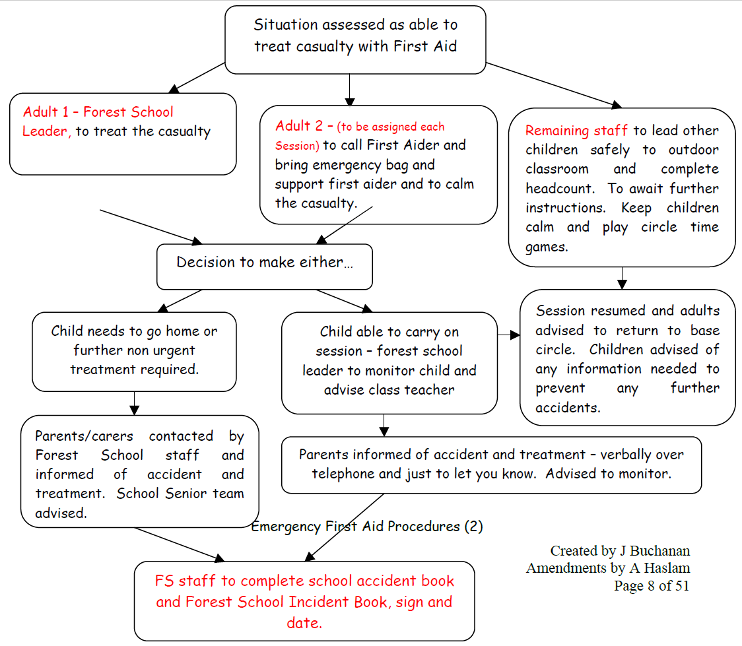

Daily Operating Procedures
What to do before the session
Before a session takes place the Forest School Leader will carry out a daily risk assessment of the
area and will take any necessary action to ensure the site is safe before use.
The Forest School Leader will list resources required for the session on the planning. The
resources will be checked out by the Forest School Leader using the check list and all tools will be
checked before use by the Forest School Leader following the tool policy procedure. All tools and
resources are left in locked storage until required for use at the beginning of a session. Sometimes
children are encouraged to help carry and transport resources safely to the session.
The Forest School Leader will provide activity risk assessments (see risk assessments) to all staff
and volunteers at the session, to ensure that staff and volunteers are aware of any hazards
associated with an activity and the measures in place to control the risk. Before the session staff
and volunteers will be briefed on the intended structure of the session and their responsibilities.

Transport at the beginning of the session
When on the school site children will be brought to the outdoor classroom after registration by either the Forest School Leader or adult assigned to support FSL.Adults joining the session be made aware of the ratios. The class adults will advise the Forest School Leader of any changes in expected numbers. The children will change into waterproofs and appropriate footwear. The beginning of the session will follow a similar pattern each time –coming together time to recap rules and boundaries.

What to do during the session
It is the responsibility of ALL adults to make on-going risk assessments. Regular head counts are
carried out and if there is ‘any’ doubt ‘sticky elbows’ is called to bring out children
from hiding places. If any child is unaccounted for then the missing child procedure is followed.
The adults should follow the roles of the adult guidance.

What to do after the session
At the end of the session children are called using either the Forest School bird whistle or ‘sticky elbows’. Children will be encouraged by supporting adults to work together to return
resources safely, to a central location, ready for returning to storage. Children will then group in
the Forest School seating area, where a head count will take place. A reflection session or game
will take place, sometimes followed by a song. Children will be lead to storage shed to change out of waterproofs. Another headcount will take place before the children leave there turn to their classroom.
If there are remaining staff, they can stay onsite to gather resources and take back to the locked storage, where they will be checked back in using the check list by the Forest School Leader, who will be advised immediately if any tools/resources are missing and go and check the area. If there are no remaining adults then Forest School Leader to carry out steps prior to leaving Forest School area.

Evaluation for next session
During and following a session, Forest School assistants will ensure they provide their observational
notes to the Forest School Leader to enable them to plan, according to the children’s needs, for
the next session.

Cancellation Policy
Weather conditions

Following the Forest Schools ethos of......‘there is no such thing as bad weather, only
inappropriate clothing!’ Children are advised to dress warmly and be provided with
waterproofs where needed. However, there are some occasions where it may not be safe or practical to go ahead with a planned session due to extreme weather;
• In the case of high winds of 25mph or more determined by the met office online.
• In the case of extreme temperature determined by a met office amber weather
warning.
• In the case of extreme cold of below ‘0’ a session will be cancelled if it is near to
this we will ensure children are appropriately dressed, sessions will be made shorter
and activities will be planned to ensure children are kept moving.

Staff ratios:

A session may need to be cancelled due to staff illness or other circumstances if this is
going to compromise the adult to child ratios. If a staff member is unable to attend a
session for any reason they should inform the Forest School Leader as soon as possible.
Unfortunately, cancellation decisions may be on the morning of the session, but the Forest
School Leader will endeavour to give as much warning as possible to supporting staff and
helpers. In the case of a cancellation, consultation with the class teacher will determine
whether an indoor nature or skills related session (such as knot tying and crafts),or an
outdoor learning session away from trees if the weather is suitable.

Toileting Policy

Children will be encouraged to use the toilet before beginning a session, firstly to avoid too many
trips during the session and to avoid having to take off all the waterproofs again! Adults and
children are advised that tool use will be stopped during toilet visits due to the ratio of staff
remaining.
Should a child need to go to the toilet during a session they will enter the building on the middle floor of new build classroom and use the Key Stage 2 toilets. If children are able they will escort themselves to the toilet with an adult watching from the forest school gate .If an adult needs to escort a child the Forest School Leader will be informed.
If in the rare occasion a child should have a toileting accident on site, then the adult and child will
advise the Forest School Leader who will advise Adults and children that tool use will be stopped
whilst an adult leaves the site due to the ratio of staff remaining. The adult and child can return
to the session when they are ready and advise the FS leader so that a usual session resumes.

Parental Consent and confidentiality

At Henley Green Primary School we aim, through our confidentiality statement, to ensure that staff, parents, governors and pupils are aware of the schools confidentiality policy and procedures and are aware of their responsibilities in relation to it. Any confidential information regarding children/adults is followed in the same procedure as set out in the school’s confidentiality policy.
In relation to Forest Schools, medical information for each child is obtained at the beginning of the
school year and updated throughout the year. The Forest School Leader is given a summarised list of specific medical needs for individual children (e.g. Asthma, Epilepsy, allergies). Prior the start of children beginning a session the school year parents/carers are provided with information outlining the ethos of Forest School and proposed activities.
All information about individual children is private although specific medical information that could
affect a child’s well being and safety at Forest Schools is shared with Forest School staff that
have a need to know, to ensure the best care and safety for children in our care.
Access to the emergency bag is permitted ONLY to the Forest School Leader and other teaching assistants NOT to volunteers, visitors or children. Emergency contact information is kept within the school office and can be obtained quickly from school office.

Clothing policy

Forest School leaders will provide spare clothing for those children who do not have adequate clothing and we will have a bank of spare wellies for children to use. As a responsible person, the Forest School leader will ensure only children who are suitably dressed for the weather conditions will participate.
Children will be provided with waterproof dungarees or trousers to protect themselves and clothing from the elements. Available is a limited selection of wellies, spare clothing, coats, socks and gloves should the children not have any. However for their own comfort children are encouraged to provide their own extra layers in winter. Some possible items the children could wear:

Winter
Vest or T-shirt
Long sleeved top
Hooded top / fleece or thick jumper
Waterproof jacket
Thick socks (thermal or two pairs of thin ones)
Trousers
Wellington boots
Hat, gloves and scarf.

Summer
Long sleeved T-shirt or top
Light trousers (Arms and legs must be covered in the woodland)
Socks
Trainers, sturdy shoes or Wellington boots. (Sandals, crocs and flip-flops are not suitable.)
Sunhat
Participants are also responsible for providing and applying their own sunscreen themselves in line
with the usual school practice. If insect repellent is required the usual ‘administration of
medicines’ procedure will be followed.

Tool Handling policy
Tool usage
Children will not be using tools until the Forest Leader feels the children are ready.
Specific tool policies are in place for each tool that may be used within Forest Schools; these can
be found in the appendices. The policies cover specific ratios for tool usage and any PPE required
for adults or children whilst using the tools. All tools are initially modelled by the Forest School
Leader to children and adults as set in the ratios determined by the tool policy. All Adults
participating must receive basic training on the safe use of tools before being allowed to use them
with children.

Tool Maintenance
As tools are prepared for the beginning of a session, tool safety checks are completed by the
Forest School Leader. If any tools are deemed unsafe for purpose, they are marked with fragile
tape and are moved to the designated damaged tools area, in the locked shed so they are not used.
Through safe modelling of tools, in initial 1:1 ratios, children and adults are taught how to check a
tool before using as a matter of routine. If they notice a tool is unsafe in any way to use they are
taught to use the fragile tape to highlight a tool is unsafe. If they are unable to do this then they
are taught to advise an adult so they can mark off the tool as unsafe. Children and adults are
taught that if they see a tool marked with fragile tape then they are not to use the tool because it
is unsafe to do so.
Following a Forest School session tools are checked back in by the Forest School Leader or adults.
Tools are checked against the checking out list to ensure no tools are missing. The Forest School
Leader will be advised immediately if any tools/resources are missing. As tools are returned they
are cleaned and maintained following the specific tool policy.

Tool rules - Children are taught these and they are reinforced at the beginning of each session.
- Ask an adult before you take a tool from the tool area.
- You must have a purpose for your tool.
- You must make sure you choose a safe working area with nobody near you (arms- length)
- Must wear a glove on the non-tool hand.
- Must follow the instruction on how to use the tool safely
- When finished using the tool to be put back in tool bag correctly and safely.

Fire Policy

Fires will only be lit by a Forest School Leader following this safety policy when the Forest School Leader feels the children are ready and it is appropriate.
Considerations  before deciding  to have a fire: | - Wind direction.  - No combustible materials nearby/over hanging branches.  - Firm ground
Safety -clothing  and hair: | - No hair/Jewellery dangling – hair tied back.  - No gloves on when placing materials.
Safe Sitting: | - Seating should be positioned 1.5m away from fire.  - Allow gaps for between seating arrangements for escape routes.  - Ensure the area between the seating area and fire pit is free from debris and trip hazards.  - Children will be taught they must never the cross the inside ring and taught to move by stepping over the seating log and walking outside the seating area.  - Seating in line of smoke will be avoided. Children will be taught to turn their heads if smoke is coming in their direction.
Safe  Management: | - Fires will be lit by the Forest School Leader and only when the leader is confident the group is able to carry out instructions safely.  - Fires will be lit using a fire steel, Vaseline and cotton wool - matches and firelighters can and may be used but will be stored safely away in a fire proof box. No flammable liquids will be used to light or accelerate fires.  - Never leave the fire unattended.  - Have a bucket of water available to extinguish the fire.  - The fire will be lit in a designated area used only for this purpose  - The area will be cleared of dried leaves, wood and rocks.
Safe  Extinguishing: | - Pour water over until embers are out and stop smoking  - Spread out the embers of the fire.  - check for signs of smoke or burning embers and then apply further water if necessary.
Emergency | School Fire Action plan will be followed in emergency – see appendix

Food and Eating Policy

Children at Forest Schools are taught a strict NO eating rule, unless it is a specific activity led by
an adult to prepare and cook food. Initially, when children are ready they will participate in simple
cooking on the fire activities which include; toasting marshmallows/waffles and cooking damper
bread. As skills develop, this will include cooking further meat and vegetable dishes such as
vegetable kebabs, baked apples and hot dogs to name but a few! Wild food is not carried out as an
activity to avoid confusion amongst children between what is safe and unsafe to eat. There is
always a staff member present, when food is being handled and prepared.

Food preparation, transport and storage:
• Hands will be washed thoroughly and any cuts/grazes covered in the correct manner (blue
plaster or ideally gloves) before handling and preparing food.
• Any food needing preparation will be prepared in the school e.g. bread dough.
• Food will be stored in clean containers and transported in a cool bag to and from the site,
with any clean utensils and cooking pans required. The box will remain closed in between use
with food covered in bags or boxes; to avoid attracting flies and other insects.
• Raw meats will be stored separately to any other foods.
• All ‘use by’ dates will be checked on foods before eating.
• Water for cooking will be provided in cleaned sealed storage.

Handling, cooking and eating food:
• A fresh, clean, bucket of warm soapy water will be available for children to wash their hands
before handling food or utensils.
• Children are taught how to cook food safely following the activity risk assessment and fire
policy. All food will be checked by an adult to ensure it is fully cooked before eating.
• Children will be asked to sit still around the fire circle or to move to a designated eating
area from the fire to keep numbers to a minimum near the fire circle.

Clearing away and cleaning up:
• ALL food not eaten or cooked will be placed in black bin bags and disposed of in the school
bin at the end of the session by one of the adults. The area is checked to ensure there no
food traces to avoid vermin being attracted to the area.
• ALL utensils and pans will be placed in the cool box and carried away after the session and
cleaned in hot soapy water by one of the adults and stored away correctly.

Tree Climbing Policy

Within the Forest School area there are a limited amount of mature trees which are not
suitable for children to climb. Children are not permitted to climb the trees.

Safeguarding Children – Roles and responsibilities of Adults

- The below information is extracted from the Henley Green Primary School Safeguarding Policy (updated Sept 2023)
- School staff plays a particularly important role because they are in a position to identify concerns early in order to provide help for children. All staff in Henley Green have a responsibility to provide a safe environment, where children can learn;
- All staff should know what to do if a child tells them that he/she is being abused or neglected;
- All staff will be able to identify indicators of abuse;
- All staff will be made aware of; the safeguarding and child protection policy; the school behaviour policy; the staff Code of Conduct ; information about the safeguarding response to children missing in education; the role of the designated safeguarding lead and systems in Henley Green that support safeguarding and child protection;
- All staff will be provided with a copy of Part 1 of Keeping Children Safe in Education (September 2018) annually and receive annually updated training on their safeguarding roles and responsibilities;
- All staff should know what to do if a child makes a disclosure of abuse and never promise confidentiality when a child makes a disclosure;
- All staff will be made aware of the early help process and understand their role in it;
- All staff should be prepared to identify children who may benefit from early help and will discuss early help requirements with the safeguarding lead in the first instance;
- Staff may be required to support social workers and other agencies following a referral;
- All staff will be made aware of the process for making referrals to Children’s Social Care (though the MASH), understand statutory assessments and the role that they may be expected to play in such assessments;
- All staff should be prepared to make referrals to the MASH if they have concerns about a child’s welfare and understand the role that they may be expected to play in such assessments;
- All staff will receive regularly updated safeguarding and child protection training;
- All staff will receive safeguarding updates throughout the year as part of continuous professional development;
- Should be able to contribute to the development of safeguarding policy and practice.
- All staff should always seek advice from the Designated Safeguarding Lead if they are unsure; and
- All teachers should safeguard children’s wellbeing and maintain public trust in the teaching profession as part of their professional duties (Teaching Standards, 2012).

Safeguarding at Forest Schools
Through the long term process of Forest Schools, we aim to build trust and meaningful
relationships between the adults and the children. Therefore, the nature of Forest Schools means
that disclosures are more likely. Any volunteer or member of staff who finds themselves with
children telling them something which concerns them should follow these steps.

- Listen, do not interrupt especially if the child is talking freely,
- If questions are needed to clarify understanding, they should be framed in an open manner, in order to not lead the child in any way.
- Remember that you must not promise to keep a secret.
- You must report orally to the designated senior person immediately.
- All concerns about a child or young person should be reported without delay and recorded in writing using the agreed template found in the Safeguarding Policy (appendix 1).
- Your responsibility in terms of referring concerns ends at this point, but you may have a future role in terms of supporting or monitoring the child, contributing to an assessment or implementing child protection plans.

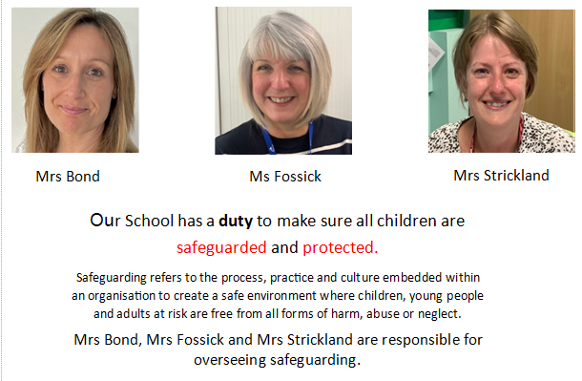

Safeguarding Adults

Guidance about acceptable conduct and safe practice will be given to all staff and volunteers during
induction. These are sensible steps that every adult should take in their daily professional conduct
with children. All staff will have access to and be expected to know our school’s Code of Conduct. There will be occasion when some form of physical contact is inevitable, for example if a child has an accident or is hurt or is in a situation of danger to themselves or others around them. Forest School Leader is Team Teach Trained (Jan 2019) and only adults with this training will safely restrain children if needed.
At Forest Schools if staff, visitors, volunteers or parent helpers are working with children they will be visible to other members of staff. Adults are asked to ensure that they can clearly see another adult when possible.

Please refer to the full Henley Green Primary School safeguarding policy for full Safeguarding information.

Lost or Missing Child Policy
Sticky elbows
Children are taught a strategy from the beginning of Forest Schools where if the adult shouts ‘Sticky elbows’ the children must come together and join elbows with children in a circle.
Throughout the sessions this can be played and also used as a call back to the base at the end of the sessions.

Boundaries
Boundaries are established with the children at the beginning of a session and children are taught
the rule of asking an adult if they wish to go beyond the boundary.
Children are involved in the risk management process of establishing boundaries and safe areas to go. Initially, Forest Schools is carried out on site.
If a child leaves the Forest School boundaries, the outer school gates are locked during the day and the access into the school is via middle floor door for toilet access during Forest Schools.

Headcounts
At the beginning, during a session and at the end headcounts take place. The number of children
and adults participating, can be found at the top of the daily risk assessment where the ratio of
adults to children has been calculated for the session. It is the responsibility of all adults
participating to ensure they are aware of the headcount for the session and to be involved in the
monitoring of this.

Ratios of adults and role of the adult
The ratios of adults to children at Forest Schools (minimum 1:7/8) ensure that children are well
supervised and supported in their learning and development. Adults are expected to spread out in
the Forest School area and be able to see children but not impose on children. They need to be
clearly visible so that children can locate an adult should they need to in an emergency.
Group sizes should not exceed 15 children. This is not only to allow for physical safety but also to allow the forest school ethos to have maximum effect.

Behaviour

At Forest Schools we encourage positive behaviour and learning through:
- Building relationships and trust; It is vital for children to trust adults if the experience is
to be a positive one.
- Through building relationships in Forest Schools, adults can gain an understanding of children’s emotional difficulties (frustration/anger, etc) and the triggers which may cause behavioural changes of fight or flight.
- As trust is built, we can teach children coping strategies and use reflection opportunities to talk about feelings and emotions enabling children to become emotionally literate and aware of feelings and aware of who we are.
- Adult’s model positive behaviour and create a positive site atmosphere where everybody is treated as equals.
- Consistent boundaries give children security, and enable them to know what to expect. A good way is to involve and engage the children in setting the rules and boundaries. Rules and boundaries are reinforced at the beginning of each session.
- Setting up opportunities for children to learn to work together; developing social skills, sharing resources, trying new activities.
- Being in the natural environment, Forest School naturally creates a calming environment setting up activities enabling children to achieve.

Rewards
At Forest Schools we aim to build children’s self esteem and confidence through self appraisal and
own sense of achievement, through the completion of activities. Adults at Forest Schools facilitate
learning to ensure that children achieve. Achieving a task will lead to a positive learning experience
and children recognising a sense of personal competence. Children with low self esteem find it
difficult to receive praise and only hear what they want to hear (biased scanning). When giving
praise it should be for recognising skills and asking how it made the child feel. We will share items
made (with permission of the children) with the rest of the group to celebrate individual success.

Sanctions
If a child’s behaviour becomes unsafe to themself or others then that behaviour needs to be
stopped, and every measure taken to prevent a situation escalating. If needed the child will be
removed from the forest school area. The behaviour code in line with our Core Values will be adhered to in the Forest School area as it would be in school.
Incidents will be recorded in the class behaviour book / CPOMS and the class teacher informed.
If repeated unsafe behaviour then further discussions to involve the head teacher to establish the
next course of action.

Roles and Responsibilities of Adults and Volunteers

1:7/8 maximum ratios of adults to children are in place to ensure that the sessions are of high quality and children have access to risk taking, in a safe and supported way. It is expected that all adults will
take an active part in all the activities; this will involve getting muddy! Where possible, Forest Schools aims to be child led using a range of activities, you are expected to support the children (not take over) to enable them to achieve a task and develop their self -esteem. Demonstrate how to do things, take an active role and extend their learning through open ended questioning, modelling new skills (e.g. knot tying) and sharing their enjoyment of their new experiences. Getting to know the children, developing relationships and building trust is vital to understanding and developing the children’s emotional needs.

Other roles and responsibilities include:
- Ensure before taking part you have read the Forest School Handbook and signed the policies and procedures in place.
- Before the session takes place take time to read the plans for that session and refer to any
related risk assessments contained in the red file associated with the activity.
- Alert the Forest School Leader immediately if anyone (adult or child) requires first aid, or
has an accident – no matter how minor.
- ONLY use tools if the Forest School Leader has said it is okay to do so. Follow the
appropriate tool policy and lead by example when handling and using tools. Report any
concerns about the state of equipment immediately.
- Lead by example and follow the Forest School Rules and reinforce them to children
throughout the session.
- Be aware of the location of the First Aid kit.
- Only tend the fire to extinguish in an emergency, or if agreed beforehand with the Forest
school Leader and you feel comfortable doing so.
- Stay within the boundaries and let the FS leader know if you need to leave the activity or
area you are supervising.
- Staff - Be aware you are duty bound under the Health and Safety at Work Act to work safely, take responsibility for your own safety and the implications of your actions, and report or remove hazards as they occur – this means use your initiative.
- Staff - Discretely gather observational notes on children according to criteria provided – a good system is to work with another adult (one to interact, and one to take notes) This could be also taking photos and uploading onto Tapestry.
- Ensure you wear appropriate waterproof clothing and footwear.
- At the end of sessions ensure you all support the FS leader with tidying away resources.

Role and Responsibility of Forest School Leader
- To ensure that planned activities and resources available are within the capabilities of the children taking part, amending plans to provide an inclusive curriculum enabling the children to achieve.
- To take responsibility for ensuring children follow the ‘core values’ during Forest School sessions.
- To have an up to date First Aid qualification.
- To ensure that medication (e.g. epipens/inhalers) and appropriate First Aid is available at every session.
- To ensure that all participants are adequately dressed for the weather.
- To ensure that adults participating understand their role in promoting emotional intelligence, self esteem and learning at Forest Schools.
- To carry out daily risk assessments as described in the Risk Assessment Policy
- To ensure all Forest School policies are regularly reviewed and that review is informed by observations and developing knowledge of the Forest School setting.

Roles and responsibilities of children

- To take personal responsibility for their own safety as well as the safety of others.
- To listen to and follow safety information given to them.
- To bring appropriate clothing and footwear to Forest School sessions (if they have it)
- To get involved in sessions and participate fully recognising their strengths, achievements and overcoming challenges.
- Follow the Core Values behaviour code.

Evaluating, Monitoring and Assessing
In order to develop the Forest School programme and to ensure good practice is maintained,
evaluation of activities will be undertaken.

During a session
Across all classes evidence is gathered considering: self esteem/confidence, behaviour, relationships, independence/self care, communication/language, exploration/curiosity, creativity/imagination, physical/practical skills, acquiring and building on knowledge, participation, taking appropriate risks and other general observations.

At all Forest School sessions, observations on children are discussed during or after a session and
recorded. The adults can then also feedback how their Forest Schools experience and the class teacher can see if it has enhanced their learning and development within the classroom.

The evidence collected, in the form of notes and photographs, of children’s learning is collated
primarily to plan for future sessions and to develop the children’s progression in different areas.

Interaction and support for the group should always come before evidence collecting. A forest school ‘Learning Journal’ will be kept and it can be used for reflection with children
as a record of personal development and achievements. Children will have access to this book
throughout the term to view and record their own comments and reflections should they wish.

Following each session
The Forest School leader will write a reflection/evaluation of the session and plan accordingly for
the next session based on the children’s interests and learning in order to develop their skills and
learning further.

Following a block of sessions
There will be opportunities for Parents/Carers to contribute their own responses about Forest
School; through parent’s evenings, end of year report parent’s comments.

Further monitoring of Forest Schools, is carried out by the School Governing Body, informal drop-ins by the Head teacher, formal Forest School observations by external body and by Ofsted.

Tool handling Policy

Tool Handling Policy - Loppers & Secateurs
Tool used for: | For cutting wood which is thumb thickness diameter or smaller. Loppers good for children to use insread of secateurs because of their long handles and non- spring closing action.
Transporting to Forest School: | TO site in secure bag.  Loppers – on site – carry down side of body, horizontally and hold bottom arm to ensure blades are not open.  Secateurs – carry down by side with blades locked pointing down.
Safety checks: | Visual observation of tool by Forest School Leader;  Loppers - Open loppers, with curved (smiley) blade up, and rest one handle on shoulder and other in groin to avoid accidental closure whilst checking.  Secateurs – open and rest on tree branch to avoid any possible closure whilst checking.  Check for splits/cracks in handle.  Check blade straight and not cracked or damaged in any way.  Check sharpness of blade (using thumb horizontally to feel drag).  Check moving mechanisms not stiff or damaged.
PPE (personal, protective equipment) | None needed unless cutting at height and hard hat could be worn to avoid overhead risks of wood falling and causing head injury.
Additional safety equipment: | None
Safe body stance: | Standing legs apart – ensure no over reaching and user is on level ground.
Safe action: | Ensure user has no gloves on or jewellery / scarves / hair dangling  Ensure no one else is within arms length of the tool.  Loppers - Ensure when using the blades are open fully with the curved face (smiley) facing upwards and the user cuts as far into crotch of the blades for maximum leverage using two handing. Ensure when working in pairs to cut wood that children are at 90° angle.
How to clean: | Clean with oil and rag
Storage: | Store in clean, dry tool bag. Locked away when not in use for Forest School session.

Tool Handling Policy – Mallet
Tool used for: | Correct purpose: hammering pegs to secure shelter, hammering a frame into ground.
Transporting to Forest School: | In a secure tool bag.  Carry down by side holding handles.
Safety checks: | Visual observation of tool by Forest School Leader;  Check for splits/cracks in handle.  Check metal pin which joins mallet head and handle intact.  Grasp handle and head and twist to ensure no movement  Check head not cracked or damaged in any way.  Ensure user has no gloves on or jewellery / scarves / hair dangling
PPE (personal, protective equipment) | None
Additional safety equipment: | None
Ratio adult/child: | 1:1 (this ratio can be increased at the decision of the Forest School Leader depending upon the skill level of the users).
Safe body stance: | Move to the correct height. Get into 3 point stance if hammering low. If standing have legs apart.  Ensure working at safe distance from others (arms length)
Safe action: | Use the mallet ensuring to keep it straight/level in up and down motion.  Keep hand holding item being hammered safely out of the way.  Hold the mallet at the end of the handle to ensure maximum force but if struggling move hand closer to the head making smaller movements.
How to clean: | Wipe with dry cloth to remove debris
Storage: | Store in clean, dry tool bag. Locked away when not in use for Forest School session.

Tool Handling Policy – Bow Saw
Tool used for: | Sawing up pieces of wood for various purposes; e.g tree cookies, wood for den building/whittling.  Triangular Bowsaw good for coppicing.  NOTE - two types of blades – Peg tooth (regular shaped teeth) used for dead wood/both but Raker tooth blade for living wood only.
Transporting to Forest School: | In a secure box/bag with blade guards on.  Carry down by sides.
Safety checks: | Visual inspection by forest school leader.  Check metal handle for wear/damage/bends/cracks  Check teeth of blades for damage.  DO NOT CHECK SHARPNESS OF BLADE BY TOUCHING only by using. If blunt throw away safely do not get sharpened as not worth it.
PPE (personal, protective equipment) | Glove to be worn on non-tool hand
Additional safety equipment: | Advisable to have bow saws with knuckle protectors.
Ratio adult/child: | 1:1 (initially but this can be increased based on trust and skill level decision to be made by FS leader)
Safe body stance: | Kneeling on ground  Body and eyes in line with the saw  Hand not on saw gloved and supporting wood away from blade.
Safe action: | Draw and saw towards you initially 3 times (less likely to jump out) to create a groove in the wood.  Use long strokes and pull the saw rather than push.  Set up children to support by holding wood rather than rotating of the wood falling on floor.  Ensure that they keep looking down the length of the saw to keep the cut straight and level.
How to clean: | Clean using an oily paintbrush.
Storage: | In dry conditions with blade guard. Locked away when not being used for Forest Schools.

Tool Handling Policy – Fixed Blade Knife
Tool used for: | Whittling sticks; ideal for hazel, sweet chestnut, sycamore.  NOTE : yew, laurel and laburnum may be whittled but must not be cooked as they contain toxins.
Transporting to Forest School: | Secure box with knives in sheaths.
Safety checks: | Visual inspection by Forest School Leader.  Along the blade of the knife for dinks, cracks.  Check the blade is not wobbly.  Check no movement in handle.  Check sharpness of blade using thumb horizontally (not vertically!) and /or by cutting leaf / paper.
PPE (personal, protective equipment) | Non- tool hand to be gloved.
Additional safety equipment: | To identify unusable tools with bright electrical tape to alert others the tool  is unsafe to use.
Ratio adult/child: | 1:1 (initially but this can be increased based on trust and skill level decision to be made by FS leader)
Safe body stance: | 3 point stance on ground level.  1 knee raised to support arm holding wood still and secure  The position must be safe, stable and secure.
Safe action: | Model first-  Knife direction away from body.  Fist grip on knife keep knife initially vertical.  Then when bark stripped angle knife (smaller angle easier)  Use the part of the blade closest to the handle.
How to clean: | Wipe blade against the wood to remove residue.  Clean with oil / rag at the end of the session.
Storage: | In dry conditions with sheaths on. Locked away when not being used for Forest Schools.

Tool Handling Policy – Palm / hand drill
Tool used for: | Drilling holes in wood
Transporting to Forest School: | Securely in tool bag
Safety checks: | Visual inspection  Check for kinks or dinks in drill bit  Check no movement on handle or wobbly drill bit  Check sharpness of bit by making indentation in wood.
PPE (personal, protective equipment) | Non- tool hand to be gloved.
Additional safety equipment: | None
Ratio adult/child: | 1:1 (initially but this can be increased based on trust and skill level decision to be made by FS leader)
Safe body stance: | Ground level  Wood that is being drilled to be on sturdy surface NOT drilling towards /into body / hand.
Safe action: | Model first –  Placing wood on a firm, steady surface  Wearing glove on non –tool hand  Drilling down with one hand and holding wood with the other.  Holding handle to drill.
How to clean: | Wipe drill bit with rag
Storage: | In dry conditions in tool bag. Locked away when not being used for Forest Schools.

Tool Handling Policy – Bit and Brace drill
Tool used for: | Drilling larger holes in pieces of wood
Transporting to Forest School: | Securely in tool bag
Safety checks: | Visual inspection  Check for kinks or dinks in drill bit  Check no movement on handle or wobbly drill bit  Check sharpness of bit by making indentation in wood.
PPE (personal, protective equipment) | Non- tool hand to be gloved.
Additional safety equipment: | None
: Ratio adult/child | 1:1 (initially but this can be increased based on trust and skill level decision to be made by FS leader) 2 people working on tool at a time.
Safe body stance: | Ground level  Wood that is being drilled to be on sturdy surface NOT drilling towards /into body / hand.
Safe action: | Model first –  Placing wood on a firm, steady surface  Wearing glove on non –tool hand  Drilling down with one hand and another person holding wood with the other.  Holding handle to drill.  Communicating instruction with other person.

Tool Handling policy - Pumpkin Knives
Tool used for | Carving pumpkins and other vegetables.
Transporting to Forest School | Securely in tool bag
Safety checks | Visual inspection by Forest School Leader.  Along the blade of the knife for dinks, cracks.  Check the blade is not wobbly.  Check no movement in handle.  Check sharpness of blade ( using vegetation)
PPE (personal, protective equipment) | Non- tool hand to be gloved.
Additional safety equipment: | None
Ratio adult/child | 1:1 (initially but this can be increased based on trust and skill level decision to be made by FS leader) 2 people working on tool at a time.
Safe body stance: | Ground level or using the log tables. Always use the tool in a downward motion. NOT into hands or body.
Safe action | Model first –  Placing pumpkin on a firm, steady surface  Wearing glove on non –tool hand  Using a sawing action cut through with one hand.  Holding handle of pumpkin tool.  Communicating instruction with other person.

Tool Handling Policy – tent peg
Tool used for:
Transporting to Forest School: | Securely in tool bag
Safety checks: | Visual inspection  Check for kinks or dinks in drill bit  Check no movement on handle or wobbly drill bit  Check sharpness of bit by making indentation in wood.
PPE (personal, protective equipment) | Non- tool hand to be gloved.
Additional safety equipment: | None
Ratio adult/child: | 1:1 (initially but this can be increased based on trust and skill level decision to be made by FS leader) 2 people working on tool at a time.
Safe body stance: | Ground level  Wood that is being drilled to be on sturdy surface NOT drilling towards /into body / hand.
Safe action: | Model first –  Placing wood on a firm, steady surface  Wearing glove on non –tool hand  Drilling down with one hand and another person holding wood with the other.  Holding handle to drill.  Communicating instruction with other person.

How to clean: | Wipe drill bit with dry rag and oil the brace.
Storage: | In dry conditions in tool bag. Locked away when not being used for Forest Schools.

Kelly Kettle Policy
A portable device for boiling water outdoors using twigs and other natural combustible materials.
Safety Precaution: | ALWAYS remove cork and fill kettle with cold water.  ALWAYS have bucket of cold water available.  Follow fire policy.
Safe sitting: | Clear ground of litter and hazards and ensure ground is level.  Set up temporary logs around Kelly kettle.  Set up seating as fire plan with seating 1.5m away from kettle.  Children should not be left un supervised.  Children to remain seated.  If they need to leave the area they step over the back of the seating and walk around – not in the inner circle.
Ratios: | Minimum 1:7/8
How to add fuel: | Children can feed the fire with 1:1 supervision but they must have been shown how to do so safely (stick held at the end and dropped in from the side; hand should never be placed over the kettle)
Instruction how to safely lift kettle once boiled: | Once the kettle is boiled lift off using two hands and holding the handles to the sides NOT at the top. PPE – fire gloves may be worn as further protection.  Only adults move and lift kettle once boiled.
Instruction on how to safely pour: | Hold the handle with one hand and with the other hold the cork on the chain and tilt.  Ensure cups are on level ground and not being held by others when pouring hot liquid.
How to extinguish: | Remove kettle from pan.  Pour on water into pan to extinguish.  Then empty embers and spread out. Sprinkle on water  continue adding water until all embers have died out. Then spread out cold embers around woodland and cover back with leaf litter to leave no trace (tidy camp fire area if using this space).

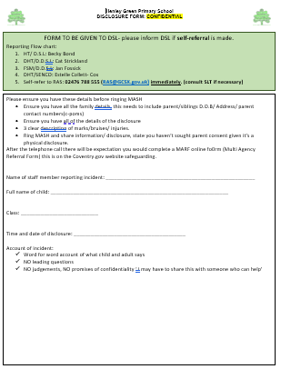

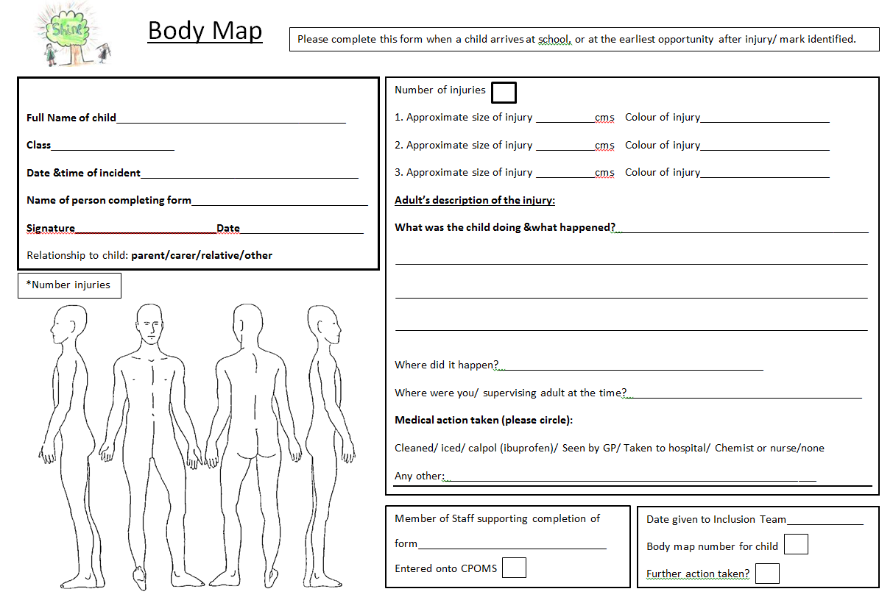

Document to be reviewed: Annually November 2019

