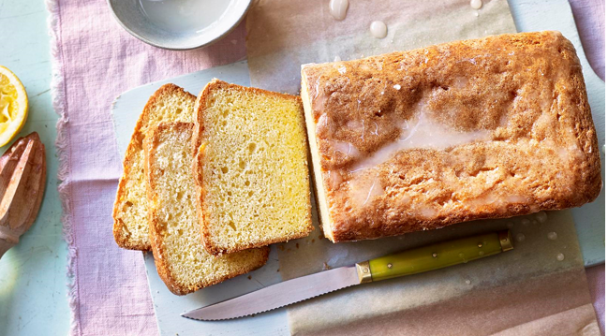
Mary Berry’s
lemon drizzle cake

Mary Berry's classic lemon drizzle cake recipe is one of our most popular recipes and you'll soon see why! It's cheap, quick and easy and something all your friends and family will love.

Ingredients
- 175g caster sugar
- 175g self-raising flour
- 175g softened butter
- 3 eggs
- Finely grated zest of 1 lemon
- ¾ level tsp baking powder
- For the lemon drizzle topping:
- 100g granulated sugar
- Juice of 1 lemon
- Special bakeware / equipment:
- Electric whisk
- A traybake or roasting, greased and lined

Method
- Preheat the oven to 180ºC, gas 4. Beat together the eggs, flour, caster sugar, butter, baking powder and lemon zest until smooth in a large mixing bowl and turn into the prepared tin.
- Bake in the pre-heated oven for about 40 mins, or until golden brown, shrinking away from the sides of the tin and springy to the touch.
- While the cake is still warm, make the lemon drizzle topping. Mix together the sugar and lemon juice, and pour over the warm cake. Leave to cool a little and loosen the sides of the cake, then lift the cake out of the tin.

